Cross-quantilogram: USDJPY and USDCAD
Method 20 / daily log returns / expanding quantiles / Alpari D1 full available history

Study setup
Logical pair: USDJPY , USDCAD
Broker symbols: USDJPY_i , USDCAD_i
Snapshot: 2026-11-03_majors_alpari_D1
Timeframe: D1
Matched return window: 1999-01-05 to 2026-11-02 (UTC bar dates)
Matched return count n: 7186
Dropped unfinished last bar dated 2026-11-03 UTC after a tick-volume check against the prior complete day.
Quantiles: expanding window, min history 252 days
tau in [0.05, 0.2]; k=0..10; headline tau=0.05, k=1
Complete matched rows (Excel): USDJPY-USDCAD_CQ_D1.xlsx
Complete matched rows (HTML table): USDJPY-USDCAD_CQ_D1_data.html

Method carried forward
The cross-quantilogram rho_tau(k) measures linkage among centered quantile-hit indicators of matched daily log returns of close, ln(close_t / close_t-1). Quotes are not inverted. At each date t, the tau-quantile uses only returns through t (expanding window) after a minimum history of 252 days. Hits are h_t = 1(r_t < q_t) - tau. rho_tau(k) is the normalized cross-product of h_x,t with h_y,t+k. Levels tau in {0.05, 0.20} and lags k=0..10 are pre-specified; headline is tau=0.05, k=1 both directions. Same-sample Pearson r is a side check. This is not causation and not a trading signal.

Results (headline)
rho_USDJPY->USDCAD(tau=0.05,k=1): 0.019852
rho_USDCAD->USDJPY(tau=0.05,k=1): 0.032386
rho_USDJPY->USDCAD(tau=0.20,k=1): 0.015863
rho_USDCAD->USDJPY(tau=0.20,k=1): 0.015864
Pearson r: 0.027603

CQ table (tau=0.05)
k | rho_USDJPY_to_USDCAD | n_USDJPY_to_USDCAD | rho_USDCAD_to_USDJPY | n_USDCAD_to_USDJPY
0 | 0.07055033 | 6935 | 0.07055033 | 6935
1 | 0.01985185 | 6934 | 0.03238584 | 6934
2 | 0.03576386 | 6933 | 0.01647923 | 6933
3 | 0.01983624 | 6932 | 0.01647141 | 6932
4 | 0.03256449 | 6931 | 0.0355426 | 6931
5 | 0.03574083 | 6930 | 0.02917522 | 6930
6 | 0.03573316 | 6929 | 0.02598761 | 6929
7 | 0.04527775 | 6928 | 0.03233969 | 6928
8 | 0.03571781 | 6927 | 0.04505174 | 6927
9 | 0.01342115 | 6926 | 0.04504415 | 6926
10 | 0.03251829 | 6925 | 0.02595664 | 6925

Conclusion
Headline tau=0.05, k=1 for USDJPY and USDCAD: rho_USDJPY->USDCAD = 0.0199; rho_USDCAD->USDJPY = 0.0324. At tau=0.20, k=1: 0.0159 and 0.0159. Same-day tau=0.05 rho(k=0) = 0.0706. Pearson r = 0.0276. This is quantile-hit linkage, not a trading signal.

Charts
Daily closes

Daily log returns

Cross-quantilogram tau=0.05
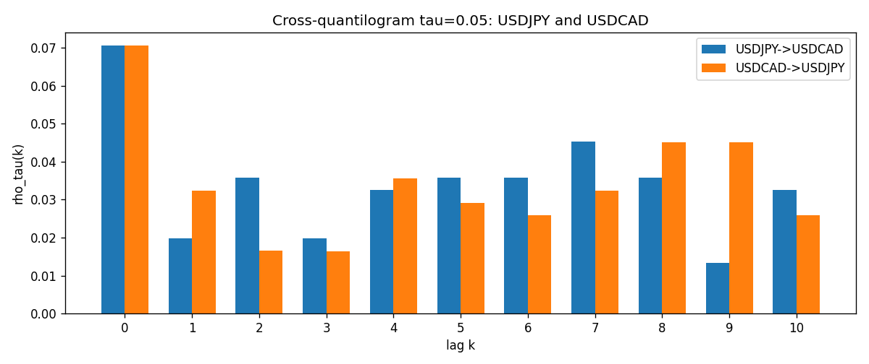

Data report
Matched rows and the CQ sheet are in the sibling Excel workbook named USDJPY-USDCAD_CQ_D1.xlsx. Embedding all rows as a Word table is impractical; this file holds column summaries and the first and last 15 matched rows.
Columns: time, USDJPY_open, USDCAD_open, USDJPY_high, USDCAD_high, USDJPY_low, USDCAD_low, USDJPY_close, USDCAD_close, USDJPY_tick_volume, USDCAD_tick_volume, USDJPY_spread, USDCAD_spread, USDJPY_real_volume, USDCAD_real_volume, USDJPY_log_return, USDCAD_log_return, USDJPY_h_t005, USDCAD_h_t005
Column summaries (matched calculation rows)
column | count | mean | std | min | 25% | 50% | 75% | max
USDJPY_open | 7186 | 113.80748 | 19.222412 | 75.693 | 104.39025 | 110.981 | 120.70625 | 163.824
USDCAD_open | 7186 | 1.266789 | 0.16892251 | 0.9168 | 1.118445 | 1.2985 | 1.37213 | 1.6183
USDJPY_high | 7186 | 114.30511 | 19.284087 | 76.001 | 104.8685 | 111.4395 | 121.2675 | 163.978
USDCAD_high | 7186 | 1.2716872 | 0.16888037 | 0.9336 | 1.122975 | 1.303895 | 1.37655 | 1.619
USDJPY_low | 7186 | 113.28446 | 19.150257 | 75.402 | 103.88 | 110.53 | 120.1715 | 163.628
USDCAD_low | 7186 | 1.2622311 | 0.16895752 | 0.9056 | 1.114125 | 1.293555 | 1.367815 | 1.6102
USDJPY_close | 7186 | 113.82065 | 19.237762 | 75.811 | 104.38275 | 111.018 | 120.69375 | 163.851
USDCAD_close | 7186 | 1.2668036 | 0.16889539 | 0.916 | 1.118165 | 1.29848 | 1.372395 | 1.6137
USDJPY_tick_volume | 7186 | 106329.64 | 179429.89 | 149 | 9948.5 | 53187 | 92874.5 | 1803508
USDCAD_tick_volume | 7186 | 81037.769 | 147318.12 | 37 | 5546.5 | 40944 | 71631 | 1410818
USDJPY_spread | 7186 | 20.270804 | 17.617829 | 0 | 6 | 11 | 30 | 50
USDCAD_spread | 7186 | 23.436682 | 18.263202 | 0 | 9 | 17 | 40 | 60
USDJPY_real_volume | 7186 | 3.4776211e+10 | 1.6092546e+11 | 0 | 0 | 0 | 0 | 3.8834203e+12
USDCAD_real_volume | 7186 | 1.8381818e+10 | 9.6701063e+10 | 0 | 0 | 0 | 0 | 2.5751613e+12
USDJPY_log_return | 7186 | 5.053e-05 | 0.00620694 | -0.03908203 | -0.00319936 | 0.00011986 | 0.0034094 | 0.05184024
USDCAD_log_return | 7186 | -1.555e-05 | 0.00514357 | -0.03859748 | -0.00283709 | 4.741e-05 | 0.00272359 | 0.03436319
USDJPY_h_t005 | 6935 | -0.00659697 | 0.20377731 | -0.05 | -0.05 | -0.05 | -0.05 | 0.95
USDCAD_h_t005 | 6935 | 0.00219899 | 0.22244413 | -0.05 | -0.05 | -0.05 | -0.05 | 0.95
First 15 matched rows (selected columns)
time | USDJPY_log_return | USDCAD_log_return | USDJPY_h_t005 | USDCAD_h_t005
1999-01-05 | -0.00017868311 | -0.010131666 | nan | nan
1999-01-06 | 0.0075660159 | -0.0003306769 | nan | nan
1999-01-07 | -0.012851583 | 0.0015202092 | nan | nan
1999-01-08 | -0.0047719894 | -0.0020495197 | nan | nan
1999-01-11 | -0.016195423 | -0.0035137769 | nan | nan
1999-01-12 | 0.032310364 | 0.0066194721 | nan | nan
1999-01-13 | 0.0081373171 | 0.0045420214 | nan | nan
1999-01-14 | 0 | 0.0069376546 | nan | nan
1999-01-15 | 0.0055343401 | -0.0056905671 | nan | nan
1999-01-18 | 8.7600193e-05 | 0.00098344542 | nan | nan
1999-01-19 | -0.0056219403 | 0.002748513 | nan | nan
1999-01-20 | -0.0053879917 | -0.0059646885 | nan | nan
1999-01-21 | 0.0084664056 | -0.0042823796 | nan | nan
1999-01-22 | 0.0060412564 | 0.0025057712 | nan | nan
1999-01-25 | -0.0073594164 | 0.00085579808 | nan | nan
Last 15 matched rows (selected columns)
time | USDJPY_log_return | USDCAD_log_return | USDJPY_h_t005 | USDCAD_h_t005
2026-10-13 | -0.0018932826 | -0.0046395653 | -0.05 | -0.05
2026-10-14 | 7.5800166e-05 | 0.0015184751 | -0.05 | -0.05
2026-10-15 | -0.0018524319 | -0.0036101503 | -0.05 | -0.05
2026-10-16 | -0.00037976126 | -0.0034322068 | -0.05 | -0.05
2026-10-19 | 0.0034946841 | -0.0018835331 | -0.05 | -0.05
2026-10-20 | -0.0022546642 | -0.0037066008 | -0.05 | -0.05
2026-10-21 | -0.00032883504 | -0.00084691787 | -0.05 | -0.05
2026-10-22 | -0.0085942669 | -0.0026307268 | -0.05 | -0.05
2026-10-23 | 0.00035080446 | 2.85545e-05 | -0.05 | -0.05
2026-10-26 | 0.0041238746 | 5.7106554e-05 | -0.05 | -0.05
2026-10-27 | 0.0027651658 | 0.0025379458 | -0.05 | -0.05
2026-10-28 | -0.00095679538 | -0.0038379274 | -0.05 | -0.05
2026-10-29 | -0.00038043789 | -0.00011436495 | -0.05 | -0.05
2026-10-30 | -0.0010596481 | -0.0010298736 | -0.05 | -0.05
2026-11-02 | 0.0026438521 | 0.00061519094 | -0.05 | -0.05

